**RUSTAM AKHUNDOV**

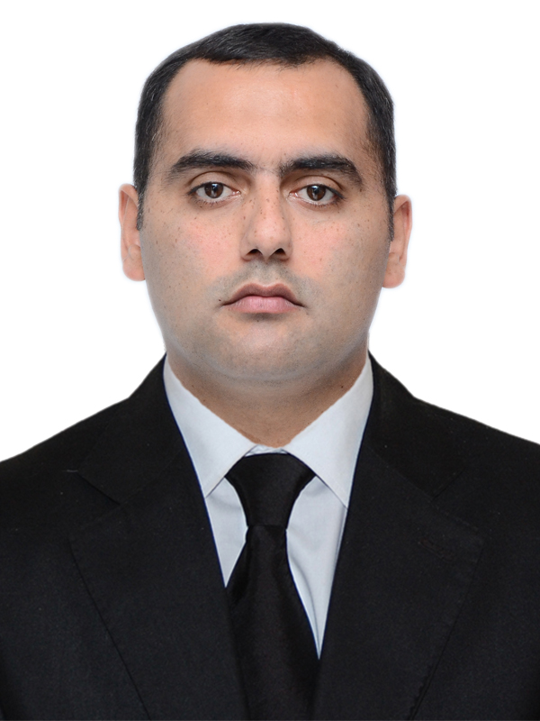

Azerbaijan rep. Khirdalan city. 26 St. f2 . 8

Azerbaijan rep. Baku city. H.Javid 70a 365

Mob: (+994) 55-678-78-76;

E-mail:[rustam.axundov86@mail.ru](mailto:rustam.axundov86@mail.ru)

[raxundov@icloud.com](mailto:raxundov@icloud.com)

DOB: 25.04.1986

# WORK CAPABILITIES

* Experience of working with various I/E test equipment for calibration and measurement of temperature, pressure, level, flow, voltage, current and other parameters.
* Technical support to process plant during normal operations and scheduled outages.
* Commissioning of HVAC Systems
* Construction and Commissioning of Flow, Pressure, Temperature, Level transmitters and devices, Control and Solenoid Valves, Junction Boxes, TCMUX Boxes. Level, Thermo, Pressure, Flow Switches. Repairs of instrument devices.
* Construction Pressure, Level and temperature gauges.
* Extensive in troubleshooting, maintenance experience for Smart (HART) and Foundation Fieldbus (FF) type field devices of all process variables and various manufacturers like, ABB, Emerson Rosemount, HONEYWELL etc.
* Skilled to read Engineering Drawings, P&IDs, Cause & Effect diagrams, Hook Ups, Wiring Diagrams, Single Line Diagrams for Electrical and I/C Installation, Schematic Diagrams, Logic Diagrams, Exploded Drawings, Detail and Instrument Loop drawings.
* Experience in Performing Preventive, Corrective and Predictive Maintenance of the field instruments and repairs.
* Calibration and Configuration of: Level, Pressure, temperature and Flow transmitters; Control and Solenoid Valves; Level, Pressure, Thermo and Flow switches.
* Verification of instrumentation equipment with DATA sheets and performing Ex inspection.
* Performing cold and hot loop checking of field instruments to junction box up to Control and LER room.
* Fire&Gas systems construction and commissioning. DGL, DGO, DFO, DGI, DSO, HSSD, DGA, MAC, EXH, DGT,
* Work with safety and control systems (ESD, F&G, DCS, ICSS). Ability to work with different types of Test equipment such as Druck Pressure Calibrator, Comparator, Dead Weight Tester (DWT), Multimeter, Millivolt Source, Milliamp Source, Decade Box, Temperature Bath, Hart Smart Calibrator, etc.

# EDUCATION

* **2003-2007 - Azerbaijan International University** - Bachelor “Oil and Gas Faculty”
* **2013-2014 -** **Azerbaijan oil Academy – Institute retraining of industrials workers**-

Instrument course

# WORK EXPERIENCE

**2019 - Present** **OFFSHORE / ONSHORE**  **Lead Engineer**

**Khazar Daniz Service**

* Onshore / Offshore Atex Inspection and Calibration of Instrument and Fire & Gas, Electrical and Mechanical equipment and devices on site
* Installation and Commissioning Electrical and Instrumentation devices Onshore / Offshore
* Calibration and Configuration Fire & Gas Devices
* Calibration Pressure relief valves, Pressure safety valves, Solenoid valves, Control valves
* Calibration of Chart Recorders
* Calibration Torque Wrenches
* Calibration Multimeters
* Calibration Debooster valves
* Calibration of pressure gauges and transmitters
* Calibration of flow elements and transmitters
* Calibration thermo elements, RTD, Temperature transmitters
* Calibration level gauges and transmitters
* Installation Instrument, Electrical and Fire & Gas Devices

**2018 - 2019 OFFSHORE Instrument and Metrology Engineer**

**SOCAR AQS**

* Control of uninterruptible exploitation and conduction of preventive and planned technical maintenance work on the control & measurement equipment located in all operational sites
* To supervise operation of control & instrumentation and automation equipment to conduct their periodic check on high level
* To determine requirements to spare parts to critical control & instrumentation and automation equipment and to prepare tables to order them
* To conduct routine and preventive repair works
* Inspection all control & instrumentation devices
* To conduct training courses with the personnel regarding ways to operate newly installed equipment and to inform them about current rules

**2016 - 2018 Instrument and Fire&Gas systems Commissioning Engineer AZFEN BP SHAH DENIZ 2 PROJECT**

* + - * Experience of using test equipment such as pressure calibrators, DPI, Decade Box, milliamp source, millivolt source, HART Communicator etc​.​
      * Commissioning of HVAC system
      * Pre-Commission/Commission of Instruments, Process Control System including Safety systems and PLC systems​.​
      * Experience in the interpretation of all engineering documents including datasheets, P & IDs, Cause & Effect Diagrams, Loop Drawings, etc​.
      * Familiar with the application of Completion Management System for the control of Pre-Commissioning activities.​
      * Ensure that the instrument and control content of the dossiers is accurate and complete before they are accepted from construction and before they are submitted to operations department.​​.
      * Hot and Cold Loop check activities​.​
      * Ensuring PTW are consistently
      * Ensuring PTW are consistently applied for to an acceptable standard
      * Active participation in the TRA process alongside with the Area Authority
      * Referring to instrument drawings or specifications as per requirements
      * Reporting of all daily activities

**2013 – 2016 Instrument Construction and Commissioning Engineer/**

**Instrument Control Engineer**

AzMeCo – Azerbaijan Methanol Plant

* Construction and Commissioning Instrument devices.
* Control PLC and DCS on board
* ​Testing, Services and checking different control valves.
* Performing plant maintenance activities.​
* Assisting engineers on site in the setup of machineries.
* Forming and assembling tubing, fitting and pipework systems.​
* Carry out Vibration monitoring.​​
* Report for procurement right spare parts, based on the
* requirements gathered from site.​
* ​Working with P&ID, Loop Drawings and other drawings.
* ​​​Participation and conducting Safety Meetings and Tool Box
* Talks.​​​

**2012 -2013 Instrument Construction Supervisor**

Caspian Construction and Commissioning Company

# CERTIFICATES

# 

* INSTRUMNET CONTROL COURSE
* CompEx ( Ex01, Ex02, Ex03, Ex04 )
* BOSIET ( INCLUDING HUET&EBS )
* AGT L1 ( AUTHORISED GAS TESTER TRAINING )
* CROWCON GAS DETECTOR CALIBRATION ( Portable )
* HSSE INDUCTION
* PLC Training Course - Developia

# LANGUAGES

* Azeri - native
* English -good
* Turkish-excellent
* Russian - good

# MILITARY

* Internal Forces ( Daxili Qoshunlar ) 2007-2008

# COMPUTER KNOWLEDGE

* Experienced user of Microsoft office products (Word, Excel, PowerPoint and Outlook AutoCad)