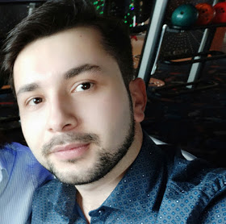 |  |  |  | Kanan/Kənan  Ramazanli/Ramazanlı

Experience
01/2018–01/2019
• intern • Esodent
01/2019–06/2019
• Luks-dent
12/2019–12/2019
• Azərbaycan Sənaye Sığorta ASC

Education
Azerbaijan Medical University, Baku,Azerbaijan
- 2011-2016

Skills

- Microsoft Office
- Analytical Skills
- Customer satisfaction
- English
- Management

About me
I am self – improving, autodidact, passionate, always learning, good with people, Versatile. I don’t let my emotions distract me. I am actually a dentist but looking for a career change.
Resulzade, line 6,
house 21
Baku, AZ1106
 |  | +994505346416  +994556942809
 |  | knnrmznl@gmail.com  kramazanli@outlook.com

Hobbies and interests

[Love reading books (George Orwell, Dale Carnegie), but haven’t read since December. Playing football. Recently learning chemistry and Spanish language. Always trying to improve myself ]

