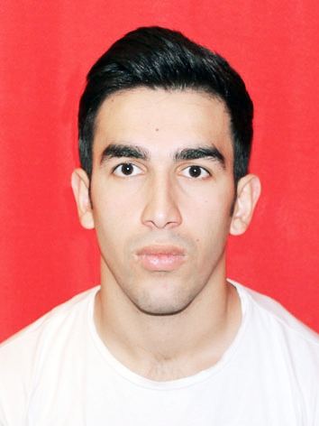

* Sex Male ǀ Date of birth 29 Nov 1996
* Citizenship
* Azerbaijan
* Post
* Engineer [Graduate]

**Amid Hacıyev**

*Chemical engineer enenrnrnengineereekdlfıfıfkengineerEngineer*

Facebook: Amid Haciyev Linkedln: Amid Hacıyev

**EDUCATION**

AZERBAİJAN STATE OİL and İNDUSTRY UNİVERSİTY

**PROFILE**

* **Bachelor in Chemical Engineering [2014–2018]**

**EXPERIENCE**

* 4TH ISLAMIC SOLIDARITY GAMES, BAKU (AZERIBAIJAN)

**Volunteer**

22 April 2017 – 12 May 2017

* FORMULA 1 2018 AZERBAİJAN GRAND PRİX

**Volunteer**

22 April 2018 – 29 April 2018

* GARANT CONSTRUCTİON İNDUSTRY FACTORY(Azerbaijan)

**İnternship**

15 February 2018 – 31 May 2018

**CONTACT**

**SKILLS**

Amid19.97@mail.ru

* **PERSONAL SKİLLS**

+994707366678

* Mother tongue---Azerbaijan

Azerbaijan, Baku

* Other languages

**HOBBIES**

|  |  |  |  |  |
| --- | --- | --- | --- | --- |
| Language | Listening | Reading | Speaking | Writing |
| English | C2 | C2 | C2 | C2 |
| Turkish | C2 | C2 | C2 | C1 |
| Russian | C2 | C2 | C2 | A1 |

Reading

Travel

Driving

Music

* I like collecting
* **DIGITAL SKILLS**
* I interested in sport and doing it.
* I always look for new things
* **COMMUNICATION SKILLS**
* Verbal Communication, Cooperation communication, empathy skills gained through volunteering programs and at university
* Mc Office HTML 5
* Adobe Photoshop Atom
* 3 Ds Max ABBYY